***Hyperledger Block Structure***

1. Block Header
2. Transactions
3. Transaction Proposal
4. Transaction Endorsements
5. Proposal Response
6. Block Metadata (who committed it? Orderer information etc.)

***Note***

Chaincode Events are generated are stored inside Proposal response

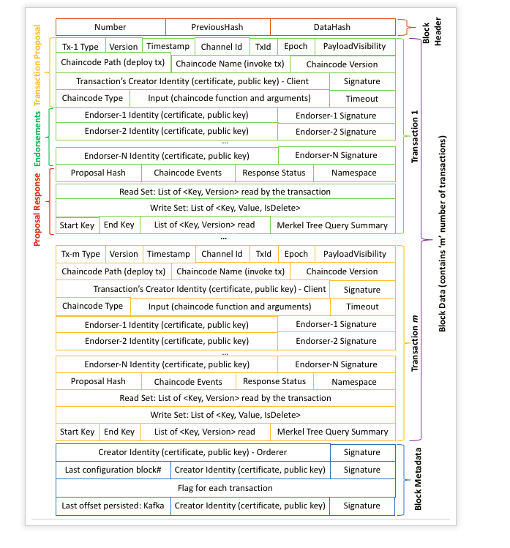

***How each Channel maintains its state, ledger***

***Every Channel has these – Three components as part of the ledger***

1. Block storage
2. State Database
3. History Database

***Block storage***

This is the actual Blockchain (Transaction logs) which are stored in the file system which are linked to each other

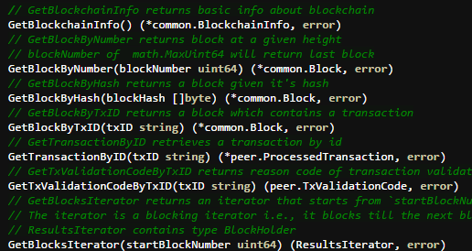

***State Database (World State) 🡪 Couch DB/Level DB***

This stores the current state of the ledger. All the recent values can be fetched from here

Set state and Delete state 🡪Put State and Del State respectively

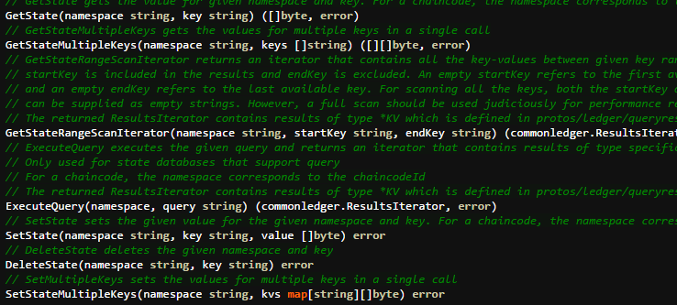

***History Database***

Since it is very in efficient to iterate the block storage to fetch (say range of keys), history DB is used (Only Level DB)

*Key Index of Block storage is stored in history DB*



***Platform comparison***

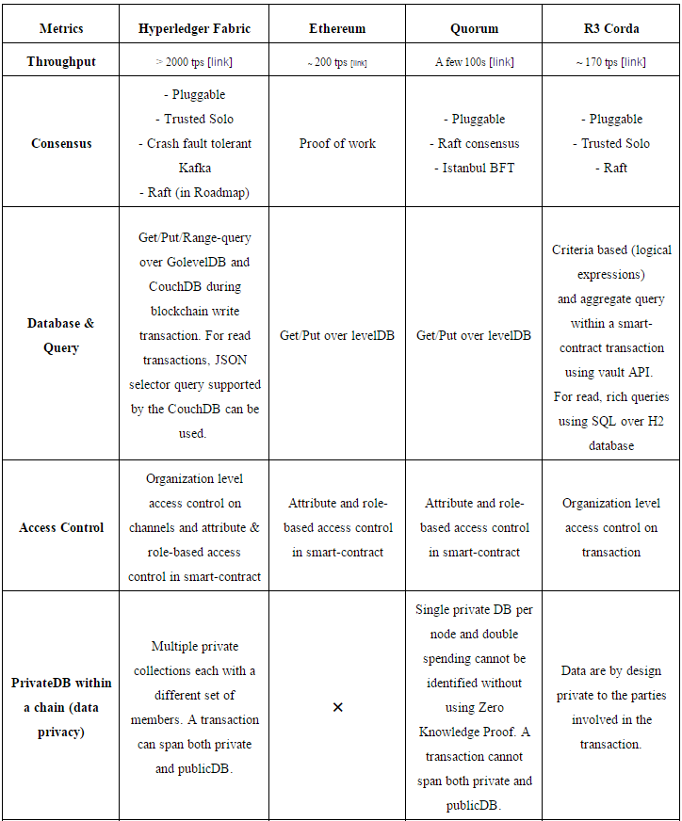

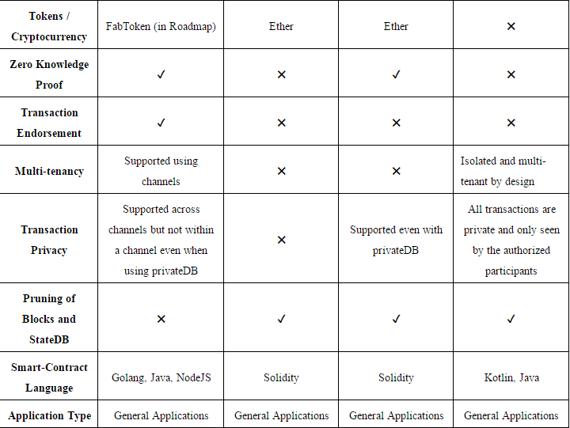

***System Chaincodes***

|  |  |  |  |  |
| --- | --- | --- | --- | --- |
| *Configuration*  *Chaincode* | *Life cycle chaincode* | *Query chaincode* | *Endorser chaincode* | *Validator chaincode* |
| peer channel join  peer chaincode query - GetConfigBlock  peer channel fetch  peer chaincode query  peer channel list | peer chaincode install  peer chaincode instantiate  peer chaincode query – getchaincodes  getinstalledchaincodes | peer chaincode query  GetBlockByNumber | executing a transaction, to put its signature on the transaction response | VSCC is invoked by the committing peer to validate each transactions' signature |